Experiment No.: 09 Intelligent Temperature Transmitter

|  |  |
| --- | --- |
| **Academic Year** | **: 2021-22 Sem : I** |
| **Class** | **: TY BTech Instrumentation & Control** |
| **Course Name** | **: Process Instrumentation** |
| **Course Code** | **: IC3231** |
| **Name** | **: Shaunak Deshpande** |
| **Division** | **: IC-C** |
| **Roll No.** | **: 39** |
| **G.R. No.** | **: 11911180** |

# Experiment No. : 9

**Two wire Intelligent RTD Temperature Transmitter**

**Aim :** Characterize the given Temperature Transmitter On Virtual Lab

**Apparatus :** Two wire temperature Intelligent RTD transmitter, current source (4-20mA), Heater, Digital Multimeter, power supply, RTD Simulator, etc.

# Theory :

A transmitter is a device which responds to a physical parameter and converts it into standard transmission signal. It sends the measured data from field to control room. In a process loop transmitters are used as a feedback device to the controller. There are mainly three types of analog transmitter 2-wire, 3-wire and 4-wire. In the two wire type same two wires are used for providing power supply and collecting control signal. This type of configuration is used when field transmitters are not self-powered or when the sensor is mounted far away from the measuring instrument. It can be connected to any temperature element and using suitable signal conditioning gives the electrical output in the range of 4-20mA. The devices that can be driven by 4- 20mA signal can be connected in series with it. It reduces the number of wires need and the cost thus easing the maintenance but because of its low input impedance capability its limits the type and number of devices driven by the signal.

A temperature transmitter works by connecting to it some form of temperature sensor For example, a RTD or thermocouple. In the case of a RTD connected to the transmitter the transmitter measures a change in resistance of the RTD proportional to the change in temperature measured.

The transmitter then derives a current output (generally 4-20mA) which can be measured by an instrument, such as µP, µC, PLC, etc. In the case of a thermocouple a mV is produced at a junction of two dissimilar metals, this change in mV again proportional to the change in temperature and the transmitter again derives a current output measurable by a instrument.

The transmitter will be ranged by a programming device, say for example an application where process temperatures need to be measured between 0-100 degrees, the transmitter will be ranged 0-100 degrees and thus give an output proportional to the temperature measured by the sensing element. 0 degrees = 4mA, 100 degrees = 20mA.

|  |  |  |  |  |  |  |
| --- | --- | --- | --- | --- | --- | --- |
| Two wire Temperature Transmitt:er  Transmitter  Power Measurement  S P PIY  **Signal Conditioning :**There are two types of signal conditioning   1. Analog signal conditioning 2. Digital signal conditioning   **Block Diagram of Digital Signal Conditioning.** | | | | | | |
| Temp  D-3DD’C | RTD | Wheatstone Bridge | ADC | Amplifier | DAC  Voltage to Current Converter | 4-20mA |

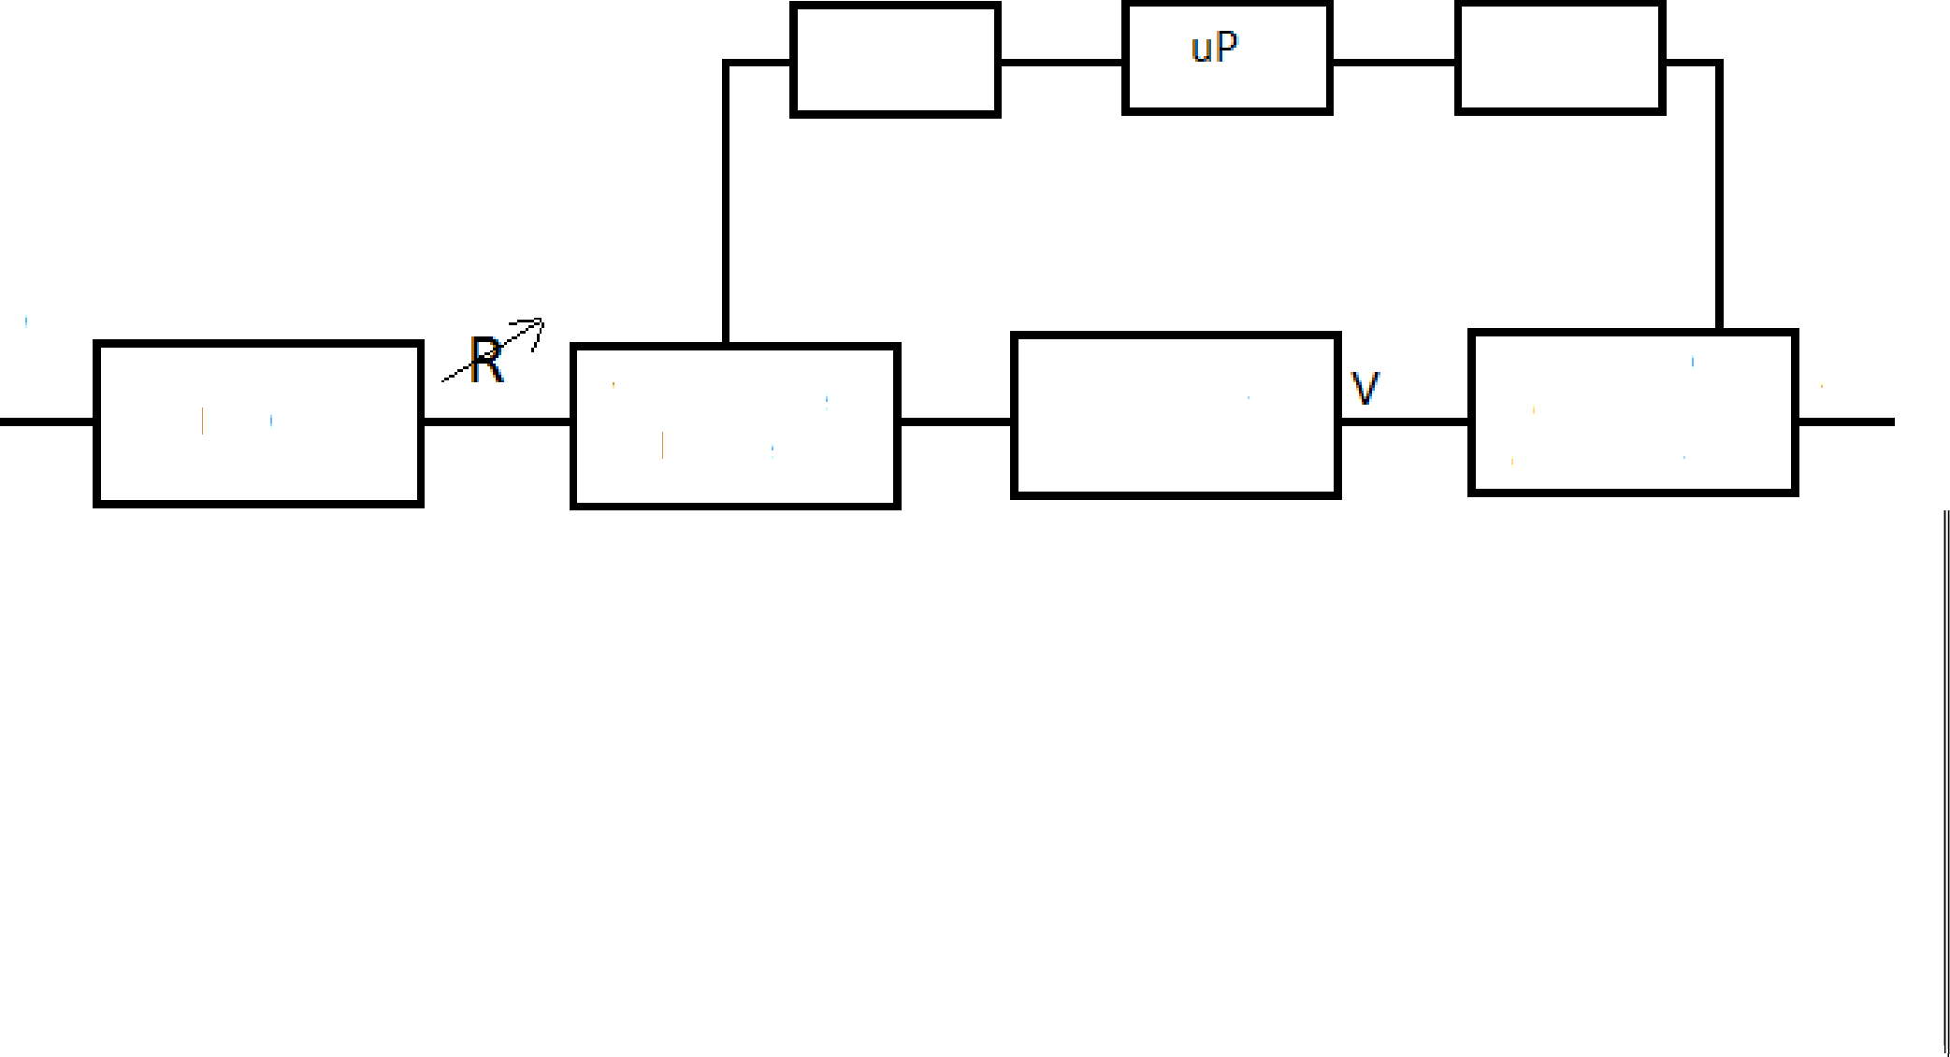



# Technical Specifications :

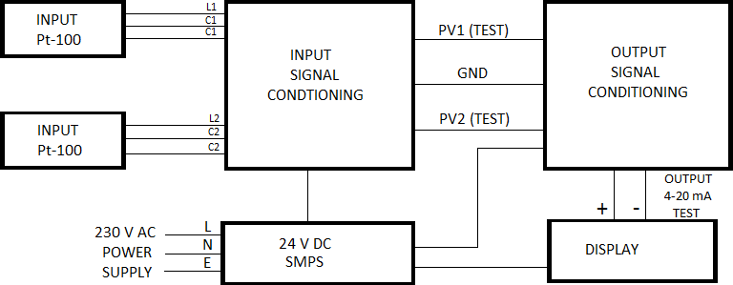

1. Instrument Name : Temperature Transmitter
2. Input : 02 No.s RTD Pt-100 (2 or 3 wire type)
3. Output : 4-20 mA DC 4. Range : 0-3000 C
4. Power Supply : 230 V AC, 50 Hz
5. Display : 8 x 1 Alphanumeric LCD display
6. Power Consumption : Less than 10 VA
7. Dimension : 300 mm (W) x 65 mm (H)
8. Enclosure : Acrylic Box
9. Mounting : Top of the Table
10. Connection : Through Pin Type Lugs
11. Operating Temperature : 0-550 C
12. Relative Humidity : 5-95 % At 250 C

# Block Diagram of Temperature Transmitter :

**Procedure :**

1. Switch on the power supply and and use RTD simulator for temperature build up.
2. Make the connections of temperature transmitter and digital Multimeter as per the circuit diagram for analog transmitter.
3. Observe the change in current output due to increase in temperature.
4. For Digital transmitter calibrate the digital temperature transmitter using the given guidelines.
5. Note the zero and spam adjustment.
6. Vary the temperature gradually by (adjusting the pot) and note down the corresponding reading.
7. Plot the graph for obtained reading of temperature vs current.
8. Calculate % error & sensitivity.

# Observation Table :

|  |  |  |  |  |
| --- | --- | --- | --- | --- |
| **Sr.**  **No.** | **Temperature (0C)** | **Output Current Expected Value (mA)** | **Output Current Measured Value (mA)** | **% Error** |
| 1. | 0 | 4 | 4.88 |  |
| 2. | 50 | 8 | 7.26 |  |
| 3. | 100 | 12 | 13.03 |  |
| 4. | 150 | 16 | 17.00 |  |
| 5. | 200 | 20 | 19.55 |  |

**Sample Calculation :**

%Error = [𝐸𝑥𝑝𝑒𝑐𝑡𝑒𝑑 −𝐴𝑐𝑡𝑢𝑎 ] 𝑥 100

𝑠𝑝𝑎𝑛

# Conclusion : learn to transmit signal from cylinder to controller using transmitter

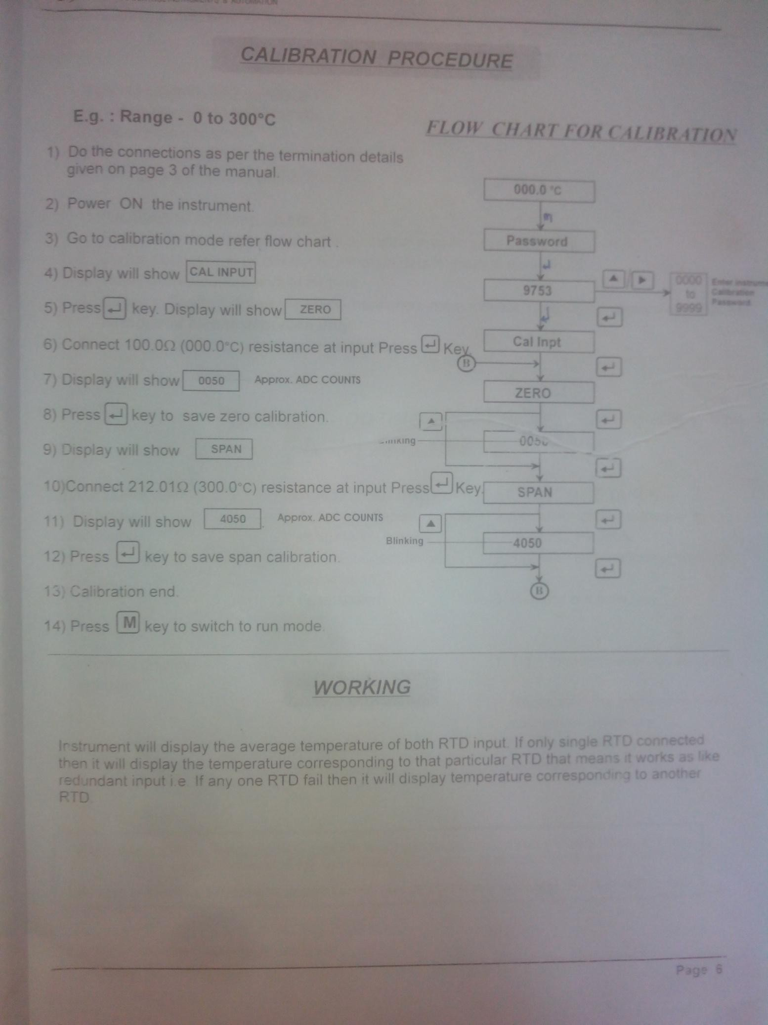

**Scale :**

On X-axis : 1 cm = 25 °C On Y-axis : 1 cm = 2 mA



# Temperature (°C)

**Screenshots of the Tasks completed on the Virtual Lab:**

(Introduction, Configuration, Connections, Characterization, Calculations, Calibration, Final observation Table, Fault Finding, etc.)

# 1.

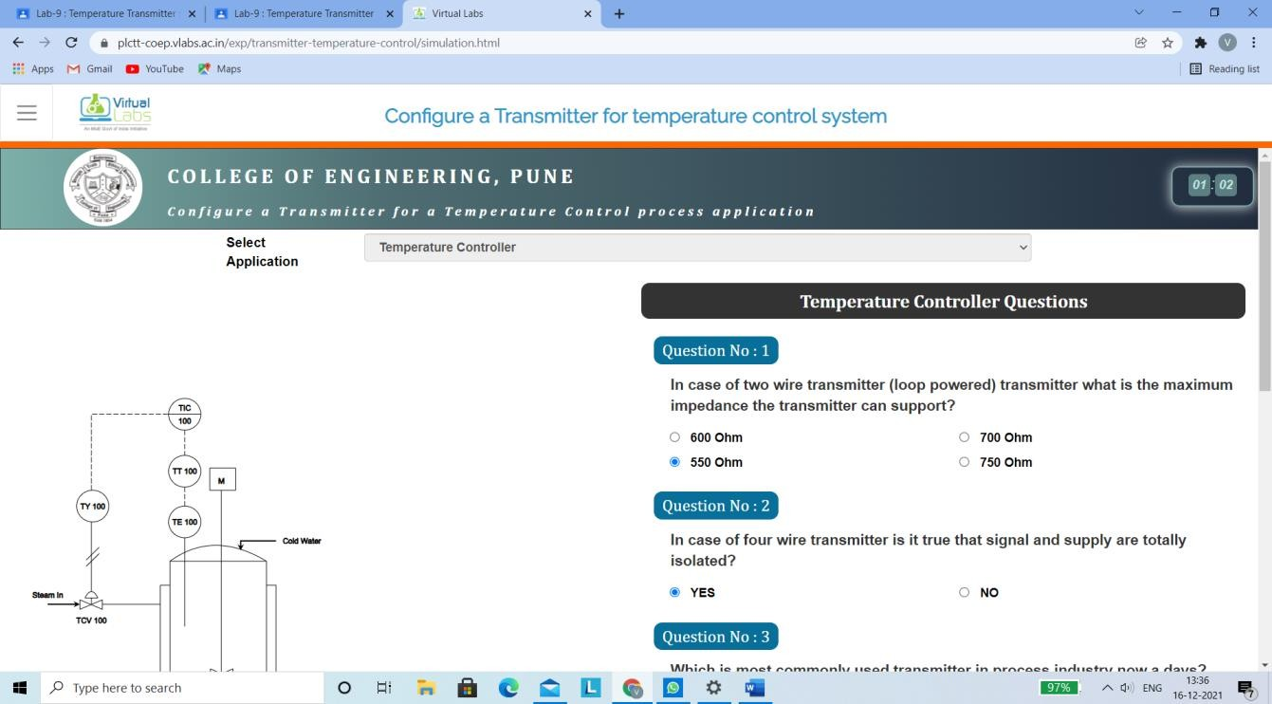

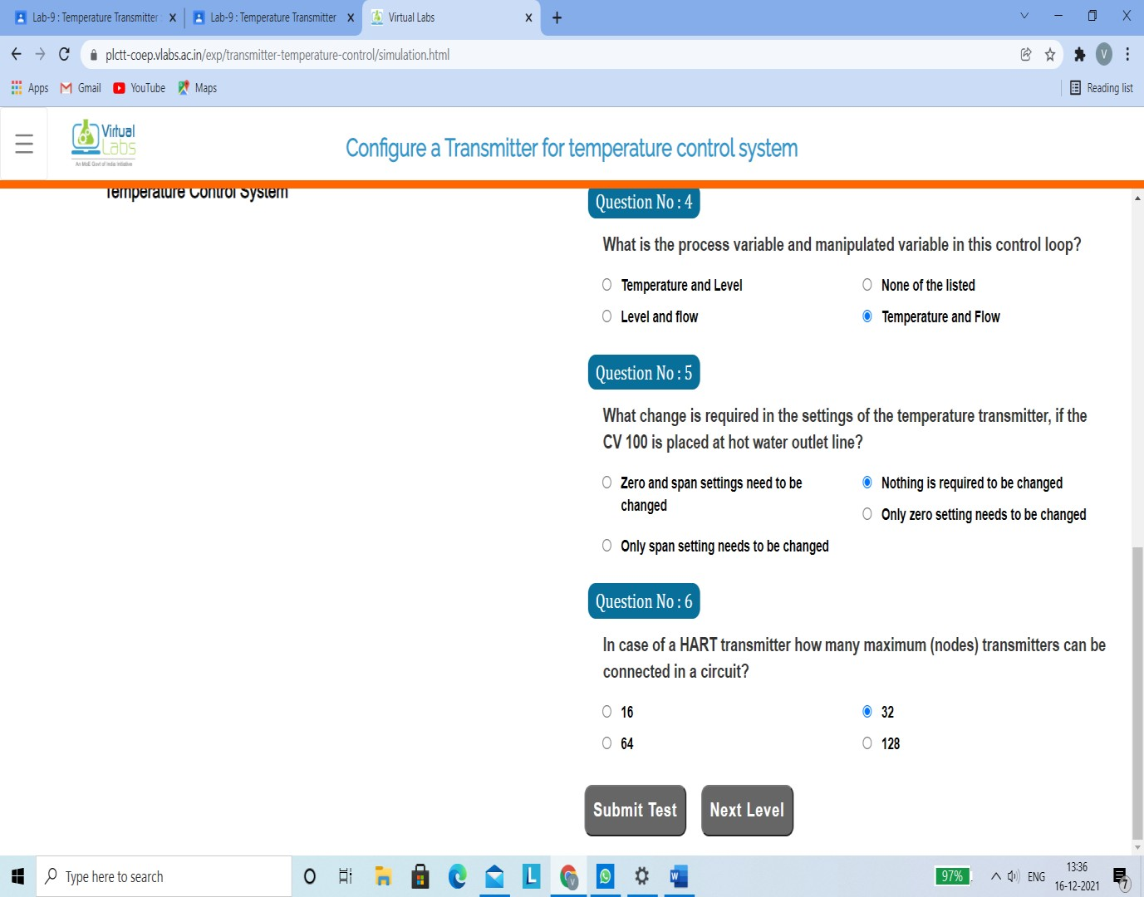

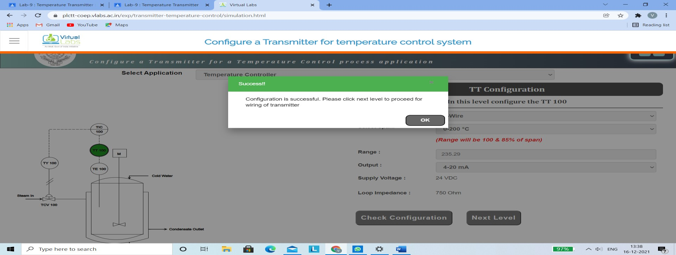

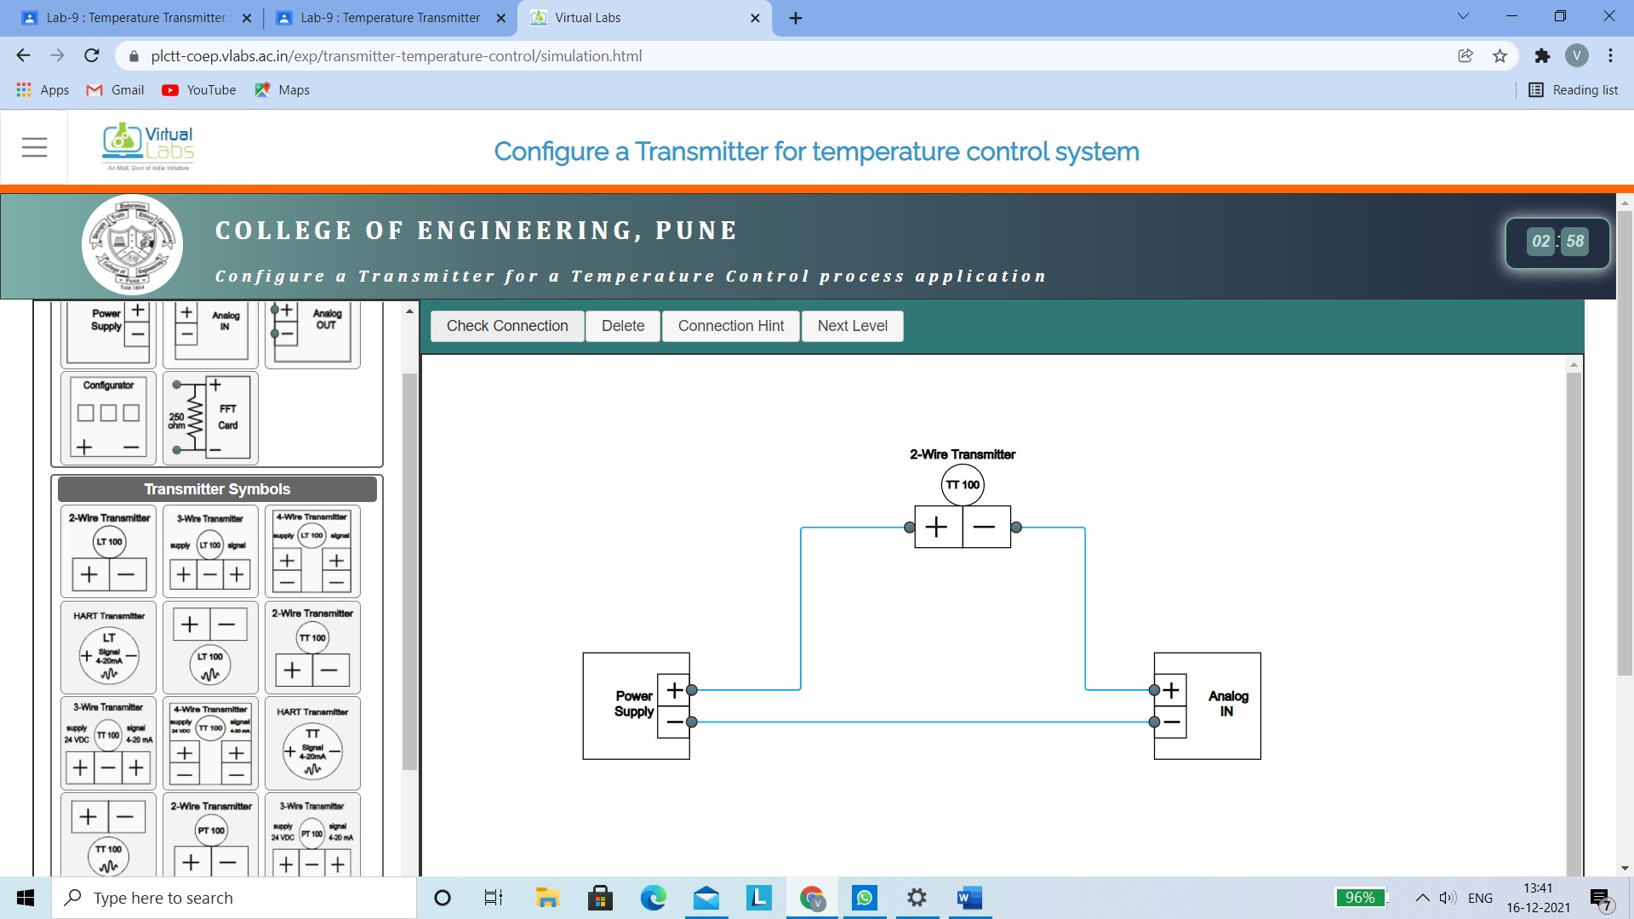



Configure a Transmitter for temperature control system

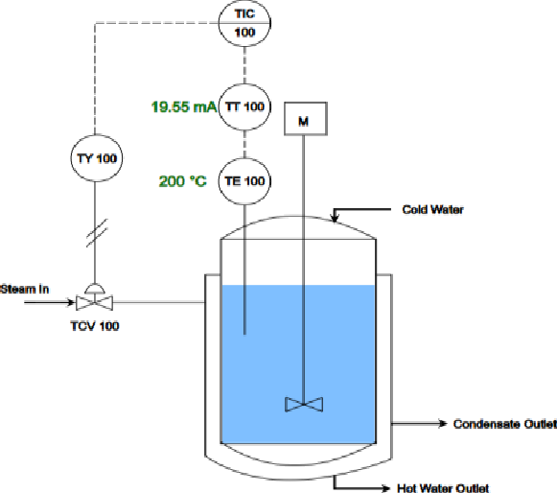Temperature Control System

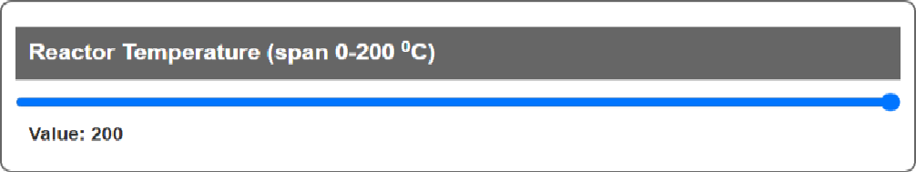

value: z00

|  |  |  |
| --- | --- | --- |
| 1 | 0 | %88 |
|  | 50 | 7.26 |
|  | 100 | 13.03 |
|  | 15D | 17.00 |
|  | 200 | 19.55 |



Tempemture Conbol Sysbm

Configure a Transmitter for temperature control system

200

Temperature Control System







Input Temperature (lph)

Configure a Transmitter for temperature control system

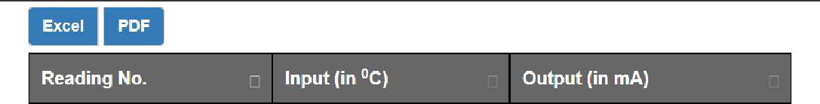In this level characterize the TT 1 00



Viilual

In this level calibrate the TT 100

Zero , Span & Linearity Adjusted successfully!!!



|  |  |  |  |  |  |
| --- | --- | --- | --- | --- | --- |
| 1 | 0 | 4.88 |  |  |  |
| 2 | 50 |  |  |  |
|  | 100 | 13.03 | 1 | 0 |
|  | 150 | 17.00 |  | 50 | 7.98 |
|  | 200 | 19.55 | 3 | 100 | 12.03 |

Showing 1 to 5 or entries

4 150 16

200 20



Viilual

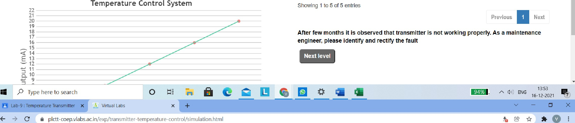

Configure a Transmitter for temperature control system

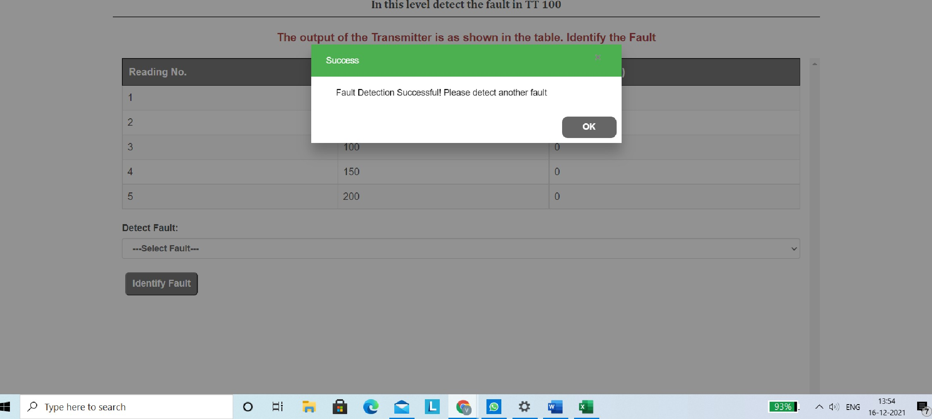



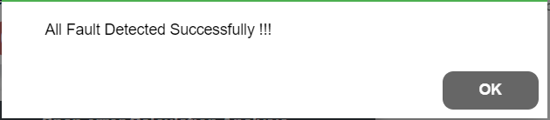



' L

